SharedHome Milestone 2 Design and Prototype Report
Role adaptive smart home interaction for administrators older adults and children
Course Human Computer Interaction
Term Fall 2026
Milestone Solution Design and Prototype Development
Team Ramz Hamza Karam

This report documents the evidence chain, conceptual design, prototype development, and iterative refinement completed for SharedHome through the Iteration 3c candidate.

Project Summary
SharedHome is a mobile smart-home prototype for multigenerational households. It changes both interface complexity and action authority while keeping adaptations and restrictions visible. The current Iteration 3c candidate combines user-selected Basic, Guided, and Full experiences with explainable restrictions, scoped access requests, shared temperature negotiation, and plain-language home rules.
Two formative reviews support continuing with role-aware layouts. Participants initially felt more comfortable but still needed time to adjust. After brief role-specific guidance, stable control placement, and clearer terminology were added, participants showed faster learning, adaptation, and completion. They responded positively to icons paired with text labels, and one participant described the prototype as a "convenient experience." These are qualitative findings because numerical task times, error counts, and participant-level outcomes were not recorded. Iteration 3c has not yet been evaluated and is reported as a design hypothesis.

Research Basis

Initial Participants
Participant | Role | Recorded finding | Evidence
Ramz | Technically comfortable administrator | Reported no difficulty using IoT controls | Direct interview
Murium | Older adult age 60 | Has difficulty navigating smart home controls | Direct interview
Ayun | Child age 10 | Requires limits on available controls | Direct interview

Evidence Boundaries
The three interviews establish differences in technical confidence and the need for child restrictions. They do not independently establish that users need restriction explanations, in-app access requests, temporary approvals, or progressive disclosure. Those interactions began as design hypotheses and were explored through the prototype. Wi-Fi and front-door controls are also hypothesis devices rather than devices reported in the initial interviews.
- The exploratory sample is small and drawn from one household context.
- Ramz is both a team member and participant, which may introduce response bias.
- The interview date, exact questions, and complete quotations are not recorded in the supplied research notes.
- The consent procedure for Ayun's direct participation should be documented in the study record.

Design Requirements
The requirements follow the course evidence chain from user problem to research finding, design requirement, HCI principle, design decision, and prototype feature. The evidence status column distinguishes interview findings from baseline usability requirements and hypotheses.
ID | Evidence status | Requirement | HCI rationale | Prototype response
DR1 | Interview supported | Present role appropriate interface complexity | Flexibility and cognitive load | Separate Administrator Elder and Child views
DR2 | Interview supported | Limit the Elder view to essential actions | Hick law and minimalist design | Large room scoped device controls
DR3 | Accessibility baseline | Make primary actions clear and easy to select | Visibility consistency and target size | Large labeled controls with visible state
DR4 | Interview supported | Restrict selected Child actions | Error prevention and safe exploration | Visible locked Wi-Fi AC and front-door controls
DR5 | Design hypothesis | Explain every unavailable action | System status and problem diagnosis | Plain language locked-control explanation
DR6 | Design hypothesis | Allow a restricted user to request access | User control and feedback | Request access action and status
DR7 | Design hypothesis | Let the administrator choose approval scope | Error prevention and reversibility | Once 1 hour Always and Deny options
DR8 | Usability baseline | Confirm each device or permission action | Visibility of system status | State changes request badges and feedback messages
DR9 | Iteration feedback | Support gradual learning and stable use | Consistency and recognition | Stable layout with dismissible Quick guides
DR10 | Iteration feedback | Pair device symbols with explicit labels | Recognition over recall | Icon name and state shown together

Conceptual Design

Personas

Murium
Murium is 60 years old and has low confidence with technology. She uses common household devices but finds smart home navigation difficult. Her interface emphasizes a few room-level controls, large targets, plain labels, and optional access to additional functions.

Ayun
Ayun is 10 years old and needs limits on available controls. His interface keeps allowed devices easy to reach and presents restricted controls as visible locked items. Wi-Fi and the front door are included as hypothesis devices for testing whether permission boundaries are understood.

Administrator
The administrator is comfortable with smart home controls and needs full device access, permission management, and efficient request handling. The interface prioritizes pending requests and shows the scope of each approval.

Scenarios and Task Flows
Scenario | Main flow | Success condition
Murium controls comfort | Open Elder view Select Fan Turn on Confirm state | Complete without help or entering settings
Ayun requests Wi-Fi | Open Child view Select locked Wi-Fi Read explanation Request access | Explain the restriction and send one request
Administrator resolves request | Open Administrator view Review request Select 1 hour Confirm | Grant only the intended device and duration

Information Architecture
- Prototype role switcher
- Administrator dashboard with requests devices and access settings
- Elder dashboard with Light Fan TV and progressive disclosure
- Child dashboard with allowed devices and visible locked controls
- Locked-control explanation request action and request status
- Approval choices for Once 1 hour Always and Deny

HCI Principles and Design Decisions
Principle | Design decision | Prototype implementation
Hick law | Reduce the number of visible choices in the Elder view | Three large primary controls with More controls hidden initially
Cognitive load reduction | Keep each role focused on its likely tasks | Role specific content and short contextual guidance
Recognition over recall | Show available devices and pair symbols with text | Icon device name and state appear together
Visibility of system status | Show the result of device and request actions | On and Off state badges pending requests and feedback messages
Error prevention | Stop restricted or high consequence actions before execution | Locked Child controls and scoped administrator approval
User control and freedom | Let users leave dialogs and reveal optional controls | Close and Escape actions plus dismissible guidance
Progressive disclosure | Delay secondary Elder controls until requested | Show more controls reveals temperature and help
Accessible target sizing | Provide generous touch areas and spacing | Large Elder tiles and clearly separated controls

Interactive Prototype
SharedHome is implemented as a sequence of clickable web prototypes with a role switcher. Cross-role state lets a request made by Ayun appear in the Administrator view and an approval return to Ayun's view. Iteration 3c merges interface adaptation from Iteration 3a with household coordination from Iteration 3b while preserving the phone-based format.

Device Scope
- Interview grounded devices include lights air conditioning television and fans.
- Wi-Fi and the front door are hypothesis devices used to test permission explanations safety boundaries and approval scope.
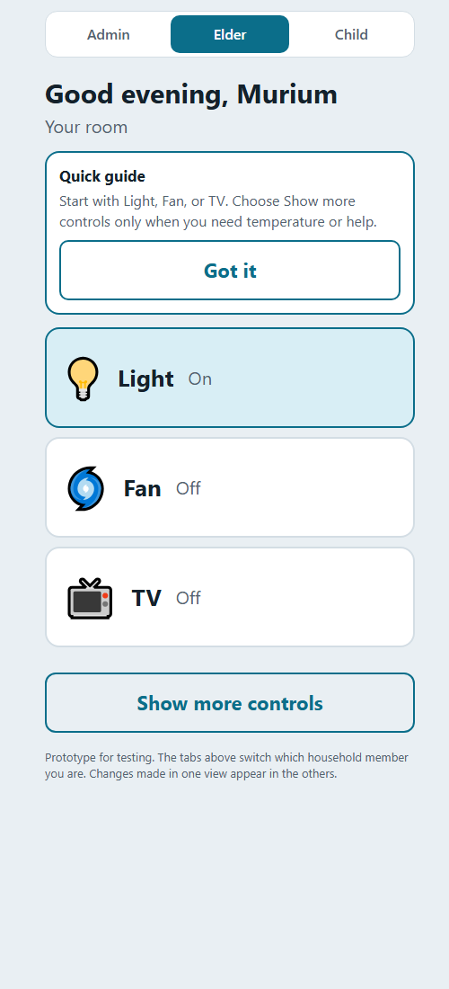  Elder view | 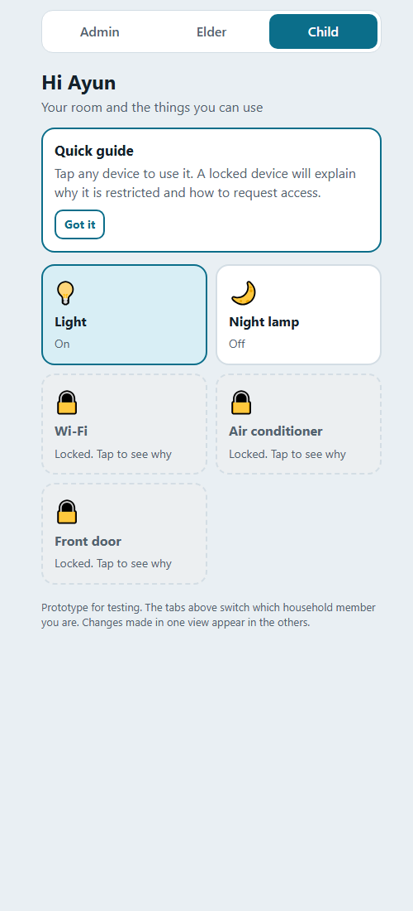  Child view
Figure 1 Role specific Elder and Child layouts

Administrator View
The Administrator view uses a denser management layout. Requests appear before device controls, and access settings expose the current permission state.
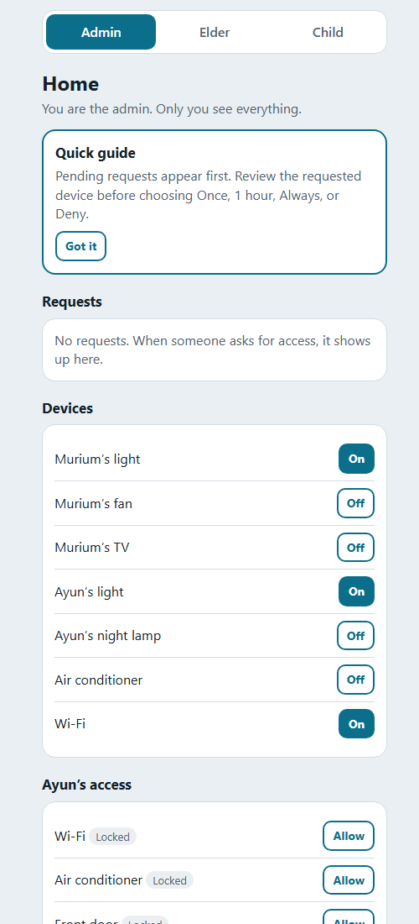
Figure 2 Administrator dashboard and access management

Iterative Refinement
The prototype developed through a baseline concept, two feedback-led refinements, and three Iteration 3 branches. The table records what changed, why the team made the change, what it achieved, and the limitation that motivated the next step.
Iteration | Change and purpose | Result and remaining limitation
0 | Established Administrator, Elder, and Child views with common device controls, visible locked items, and a request and approval flow. | Made the role-aware concept testable. Views were fixed, guidance was thin, and learning and adaptation were not addressed.
1 | Tested the role layouts with the three participants and retained Wi-Fi and the front door as explicit permission hypotheses. | Participants felt more comfortable but still needed time to adapt. No task times, errors, or attributed quotations were recorded.
2 | Added short guidance, stable device placement, consistent Administrator terminology, icon-plus-label controls, dialog focus, and Escape dismissal. | Participants reported faster learning and completion and a convenient experience. Evidence remained qualitative, and the project still needed a clearer contribution beyond role permissions.
3a | Introduced Basic, Guided, and Full experiences, transparent adaptation suggestions, four-part restriction explanations, and reversible user control. | Strengthened adaptation, accessibility, and autonomy. It did not address shared decisions or Administrator workload.
3b | Added repeated-request rule suggestions, living-room AC preference negotiation, and plain-language home rules. | Strengthened coordination and fairness questions. Several adaptation and accessibility features from 3a were absent.
3c | Merged 3a and 3b and corrected schedule labeling and rule-suggestion safety conditions. | Current candidate for evaluation. Adaptation, PACE recommendations, and schedules are simulated and unvalidated.

Participant Feedback Through Iteration 2
The first review suggested that role-specific layouts reduced some discomfort, but users still needed time to learn the arrangement. Iteration 2 kept essential controls in stable positions and placed short guidance near unfamiliar actions. The follow-up feedback indicated faster learning, adaptation, and completion. Because the team did not record task-level measurements or the speaker of the quotation below, these observations support continued design work but do not establish a measured improvement.
"Convenient experience"

Iteration 3c Candidate Prototype
Iteration 3c combines the strongest parts of both Iteration 3 branches. It keeps low-risk essential controls stable while allowing a user to select the amount of detail and guidance. It also makes household rules and shared decisions visible across roles.
- Murium can select Basic, Guided, or Full without changing her authority. A simulated recommendation explains why more controls are suggested and requires her approval.
- Ayun sees locked Wi-Fi, air-conditioning, and front-door items. The explanation identifies the reason, decision owner, available next action, and access duration.
- The Administrator sees access requests and shared AC decisions as separate workloads and can review limited approval options.
- Murium and Ayun can state different AC preferences, while the Administrator can select a compromise or one person's preference.
- Home rules show who set each restriction and why. In Murium's view they remain behind additional controls to keep the main screen simple.
- Recurring suggestions apply only to Wi-Fi and AC after two approved requests. They never apply to the front door, and the displayed schedule is explicitly simulated.

Safety and Validity Corrections
- Recurring suggestions count only approved requests. Pending or denied requests do not count, and a new suggestion does not appear while access is active.
- Accepting a recurring rule resolves any matching pending request, while the front door is always excluded from automatic rule suggestions.
- The prototype labels schedules, familiarity, and PACE recommendations as simulated. It does not claim real-time scheduling or machine learning.
Ability-based adaptation, a household co-pilot, multimodal language support, and a vendor-neutral device layer remain future work rather than implemented Iteration 3c features.
Figure 3 Iteration 3c role specific views
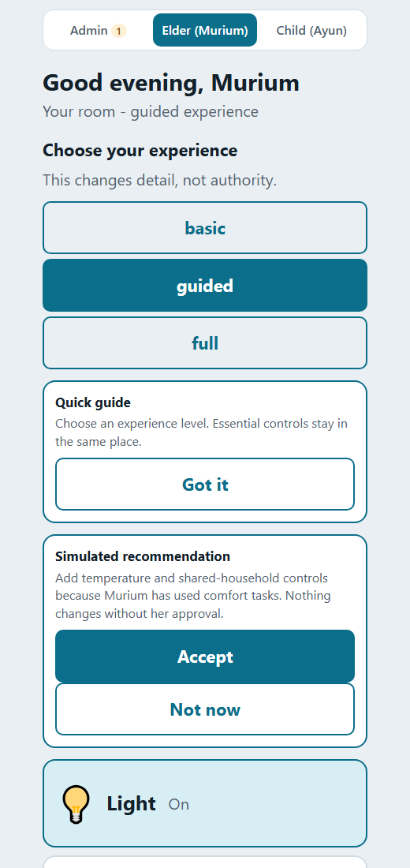 | 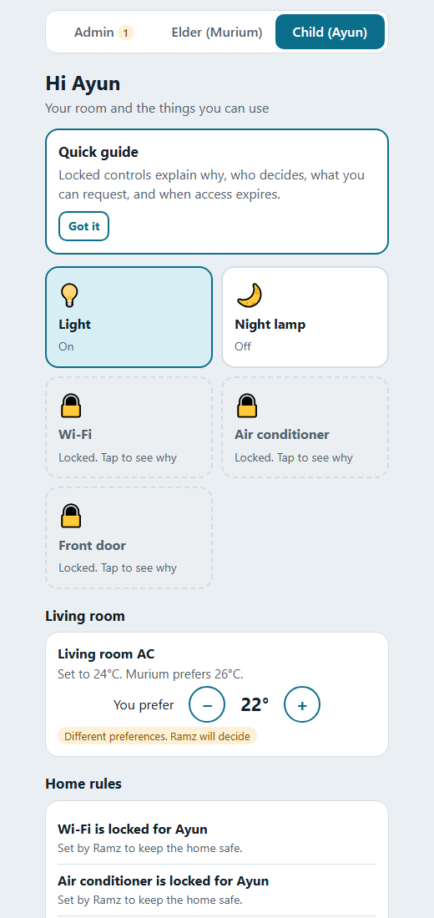
Murium's Guided experience with a transparent recommendation | Ayun's allowed and locked controls with shared AC context

Administrator Coordination View
The Administrator view separates direct access requests from shared household decisions. This distinction supports a Phase 3 comparison of routine interruption handling and preference negotiation.
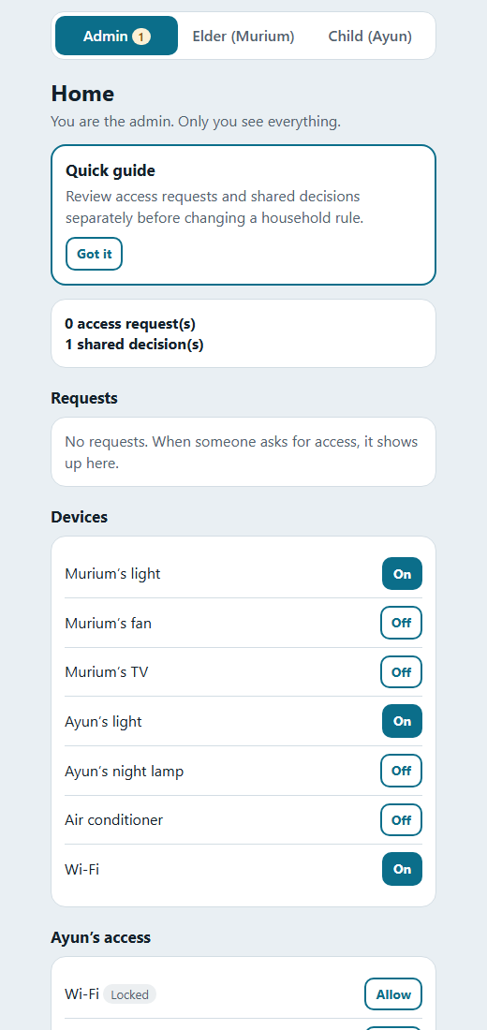
Figure 4 Administrator requests devices and shared decisions

Project Contribution and Novelty
Role permissions, child restrictions, device icons, and temporary access are not individually novel. Commercial systems already use owner, member, resident, or guest permission models. SharedHome's proposed contribution is the combined interaction model: the system changes presentation and permitted action, explains each boundary, supports a response inside the interface, and keeps recommendations under user control. This is a course-project contribution and research hypothesis, not a claim that no existing product contains any individual feature.
Design dimension | Common permission baseline | SharedHome Iteration 3c | Evidence status
Interface complexity | A role mainly changes access rights. | The user selects Basic, Guided, or Full while essential controls stay in place. | Grounded in Murium's difficulty; 3c is untested.
Restriction feedback | A control may be unavailable or limited. | The interface explains why, who decides, what can be requested, and when access expires. | Design hypothesis.
Adaptation | Settings may be personalized manually. | A recommendation gives its reason and requires Accept, Not now, or Undo. | Simulated design hypothesis.
Household conflict | An owner controls the device. | Different preferences remain visible and an Administrator resolves the AC decision. | Fairness hypothesis.
Repeated requests | The owner handles requests individually. | Two approved Wi-Fi or AC requests can trigger a simulated recurring rule. | Interruption-reduction hypothesis.

PACE Design Model
PACE is the team's proposed description of transparent adaptation. It is not a validated general model. Each dimension changes presentation, guidance, approval scope, or feedback.
Dimension | Design question | Prototype example
Person | What are this person's preferences, accessibility needs, and authority? | Murium selects Guided mode while Ayun retains limited authority.
Action risk | What could happen if the action is performed incorrectly? | Lights are low risk, Wi-Fi is moderate risk, and the front door is excluded from recurring suggestions.
Context | When and for how long is the action needed? | Ayun requests one hour of Wi-Fi; the recurring 4-to-6 schedule is visibly simulated.
Experience | How familiar is the person with the task? | A simulated recommendation appears after successful use and requires explicit acceptance.

Phase 2 Deliverable Status
The current work covers every Phase 2 deliverable in the course brief. Items marked for validation belong to the Phase 3 study and are not evaluated outcomes.
Course requirement | Completed work | Status and next evidence
Design requirements | Ten requirements connect participant evidence or hypotheses to HCI rationale and prototype responses. | Completed for Phase 2; follow-up evidence is needed for restriction and request hypotheses.
Conceptual design | Personas, scenarios, task flows, information architecture, and role-specific wireframes are documented. | Completed; the Elder label evolved into user-selected experience levels.
HCI principles | Visibility, feedback, consistency, error prevention, recognition, cognitive-load reduction, progressive disclosure, user control, and accessibility are traced to features. | Completed and traceable.
Prototype development | Clickable Iterations 0, 1, 2, 3a, 3b, and 3c support role switching and cross-role state. | Iteration 3c is the current candidate.
Iterative refinement | The log records changes, reasons, feedback, unresolved limits, and the 3a and 3b merge. | Completed through 3c; formal evaluation remains pending.

Evaluation Readiness
Phase 3 should compare Iteration 3c with a stripped-down baseline containing the same devices but a single owner model, no restriction explanations, no adaptation recommendations, and no shared negotiation. The baseline has not yet been built. A within-participant comparison can reveal usability problems, but the three-person sample cannot support broad population claims. Task order should be counterbalanced where possible.

Research Questions
- Does transparent adaptation based on person, action risk, context, and experience improve task performance and permission understanding without reducing autonomy?
- Do explainable restrictions help Ayun understand why an action is blocked, who manages it, what he can request, and when access expires?
- Do rule suggestions reduce Administrator interruptions, and does shared AC negotiation improve perceived fairness?

Planned Tasks and Measures
Persona and task | Performance evidence | Experience evidence
Murium selects Guided mode, turns on the fan, responds to a shortcut suggestion, and reverses it. | Success, time, errors, assistance, hesitation, and correct use of Accept or Not now and Undo. | Ease, confidence, perceived control, and whether the suggestion felt helpful or patronizing.
Ayun opens locked Wi-Fi, explains the restriction, requests one hour, and identifies the expiry. | Correct answers for why, who, next action, and duration; success, time, errors, and assistance. | Clarity, fairness, and whether the restriction felt like a dead end.
Ramz reviews Wi-Fi, handles the shared AC decision, and evaluates a recurring rule suggestion. | Correct person, device, action, duration, and risk; completion time; requests handled; interruptions. | Workload, confidence, recommendation usefulness, and perceived fairness.

For every task, record the date, participant, condition, completion result, time in seconds, errors, assistance, hesitation points, chosen mode or permission, and one attributed quotation. Add brief ratings for clarity, autonomy, and fairness. If the course permits, report a standardized usability questionnaire separately from qualitative comments.

Limitations and Ethics
- The evidence comes from three participants in one household context, so results will be exploratory.
- Ramz is both a team member and participant, which may introduce response bias.
- The interview date, exact questions, recruitment details, and complete quotations remain undocumented in the supplied notes.
- The study record should document guardian permission and age-appropriate assent for Ayun's participation.
- Earlier reviews did not record numerical task times, error counts, or participant-level results, and the speaker of "convenient experience" is unknown.
- Wi-Fi and the front door are test scenarios rather than devices reported in the original interviews.
- PACE, adaptation, scheduling, and recurring-rule behavior are simulated. No machine learning or real-time schedule is operating.
- Ability-based adaptation, a household co-pilot, multimodal language support, and a vendor-neutral device layer remain future work.

Team Responsibilities
Owner | Deliverables
Ramz | Design requirements, evidence-to-feature chain, and HCI principle justification.
Hamza | Wireframes, information architecture, interactive prototypes, and prototype implementation.
Karam | Personas, scenarios, user flows, task models, evaluation records, and iteration log.

Conclusion
SharedHome now meets the Phase 2 goal of translating user evidence into an interactive, theory-grounded prototype. Iterations 0 through 2 established role-aware layouts, stable controls, contextual guidance, and icon-plus-label presentation. Iteration 3c adds transparent user-controlled adaptation, explainable restrictions, scoped access, and household negotiation. Its value has not yet been established through formal testing. The next step is to build the stripped-down baseline and evaluate both conditions with recorded task performance, permission comprehension, autonomy, Administrator interruptions, and fairness.

References
Apple. (2026). Allow others to control accessories in your home. Apple Support. https://support.apple.com/guide/iphone/iphcbaf7e8f3/ios
Ghorayeb, A., Comber, R., and Gooberman-Hill, R. (2023). Older adults' perspectives of smart home technology: Are we developing the technology that older people want? International Journal of Human-Computer Studies, 170, 102979. https://doi.org/10.1016/j.ijhcs.2022.102979
Google. (2026). Share a home and devices in the Google Home app. Google Nest Help. https://support.google.com/googlenest/answer/9155535
Hick, W. E. (1952). On the rate of gain of information. Quarterly Journal of Experimental Psychology, 4(1), 11-26. https://doi.org/10.1080/17470215208416600
Nielsen, J. (1994). 10 usability heuristics for user interface design. Nielsen Norman Group. https://www.nngroup.com/articles/ten-usability-heuristics/
Norman, D. A. (2013). The design of everyday things. Revised and expanded edition. Basic Books.
World Wide Web Consortium. (2023). Web Content Accessibility Guidelines 2.2. https://www.w3.org/TR/WCAG22/

